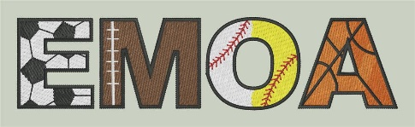

**Eastern Michigan Officials Association**

# **2025-2026**

# **Membership Application**

## ANNUAL ASSOCIATION DUES $20.00 includes one registered sport.

## Add $5 for each additional registered sport

* Membership dues are due by September 1 of each school year for returning and fall sports officials.
* November 1 is the deadline for new officials working winter sports.
* March 1 is the deadline for new officials working spring sports.

**PLEASE COMPLETE ENTIRE FORM TO ENSURE ACCURATE RECORDS**

|  |  |
| --- | --- |
| Name: ___________________________________ | MHSAA ID #: ____________________________________ |
| Address: __________________________________ | Email Address: ___________________________________ |
| City: _____________________________________ | Cell/Home Phone: _________________________________ |
| Zip: __________________________________________ | Work Phone: _____________________________________ |
|  |  |

Registered Sports – (Check all that apply)

__ Soccer __ Football ___ Basketball __ Baseball __ Softball

List Other Officials Association Memberships ____________________________________

_________________________________________________________________________

Please note that in order to be eligible to work post season MHSAA tournament games, officials must be a *Member In Good Standing* (MIGS) with an approved association which requires paid annual dues and attendance at half of the EMOA rules meetings/training sessions for each sport.

All official EMOA communications will be done by email through Arbiter. *All EMOA members must maintain an email address and monitor the inbox regularly to ensure they receive Association messages in a timely fashion.

Association dues can be mailed to: EMOA Treasurer

508 Rochelle Ct

East China, MI 48054

Checks must be made payable to: EMOA